1. KPIs Overview

Finding:
Total patients are 6183, with an average age of 61 and a high risk score of 0.84.

Impact:
The hospital is dealing with an older, high-risk population, which typically requires longer care and increases bed occupancy.
Action:
- Prioritize high-risk patient monitoring
- Allocate specialized care units for elderly patients
- Improve preventive care programs

2. Region-wise Patient Distribution

Finding:
South region has the highest share (~24.7%), while Central has the lowest (~15.8%).

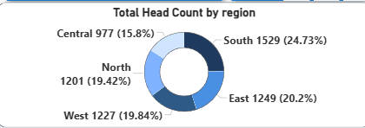

Impact:
Uneven regional demand may lead to resource strain in high-demand regions, affecting bed availability.
Action:
- Allocate more beds and staff to high-demand regions
- Improve regional healthcare distribution
- Enable patient load balancing

3. Follow-up by Insurance Type

Finding:
Medicare and Private patients have the highest follow-ups, while uninsured patients have the lowest.

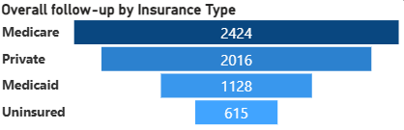

Impact:
Lower follow-up among uninsured patients increases readmission risk, leading to inefficient bed utilization.
Action:
- Improve access to follow-up care for uninsured patients
- Introduce subsidized care programs
- Strengthen post-discharge engagement

4. Length of Stay vs Comorbidities (Scatter Plot)

Finding:
Patients with higher comorbidities tend to have longer hospital stays, with dense clustering around 5–8 comorbidities and 6–10 days stay.

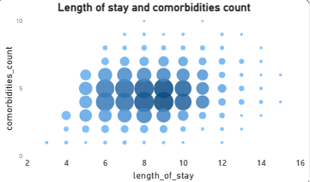
Impact:
High comorbidity patients block beds longer, reducing turnover and increasing waiting time.
Action:
- Identify high-risk patients early
- Implement specialized multi-condition care pathways
- Improve care coordination

5. Top 5 Primary Diagnoses (Count)

Finding:
Diabetes, Hypertension, and COPD are the most common diagnoses.

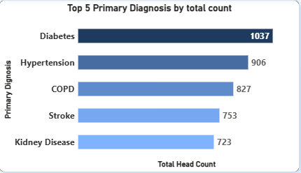

Impact:
Chronic diseases drive continuous hospital admissions, increasing long-term bed occupancy.
Action:
- Strengthen outpatient and preventive care
- Promote disease management programs
- Reduce avoidable admissions

6. Length of Stay by Diagnosis
Finding:
Stroke (10 days) and COPD (9 days) have the highest length of stay.
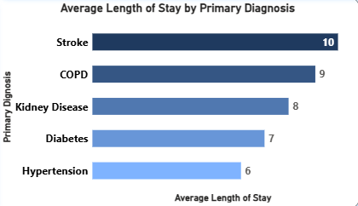

Impact:
These conditions significantly reduce bed turnover, creating bottlenecks in hospital capacity.
Action:
- Introduce fast-track discharge protocols
- Improve rehabilitation and post-care support
- Optimize treatment pathways

7. Treatment Type Distribution
Finding:
Medical treatments dominate (~44.6%), followed by surgical and interventional.

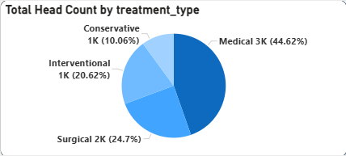

Impact:
Medical (chronic) cases require longer monitoring, increasing bed occupancy over time.
Action:
- Expand outpatient treatment options
- Encourage home-based care
- Reduce unnecessary admissions

8. Seasonal Length of Stay
Finding:
Winter has the highest average length of stay (9 days).
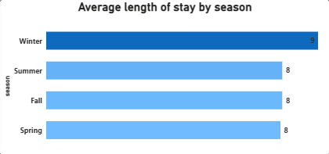

Impact:
Beds remain occupied longer during winter, reducing availability and increasing pressure.
Action:
- Prepare for seasonal demand spikes
- Increase bed and staff capacity in winter
- Plan resource allocation proactively

9. Admission Trends by Month and Day

Finding:
Patient admissions are highest in December and January, indicating seasonal peaks. Additionally, day-wise analysis shows higher patient volumes during mid-month periods (9–16 and 17–24), with noticeable variation across different days.

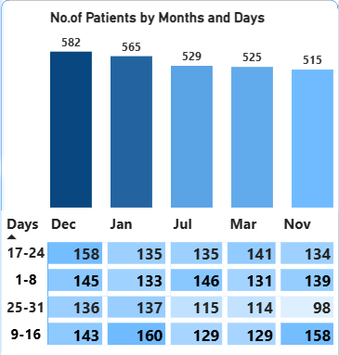

Impact:
Seasonal spikes combined with uneven day-wise distribution can lead to sudden surges in patient load. This creates pressure on hospital resources, reduces bed availability, and may result in staff overload during peak periods.

Action:

- Implement demand forecasting based on historical trends
- Increase staffing and bed capacity during peak months
- Optimize staff scheduling to handle high-demand days
- Improve patient flow management to balance workload evenly

Final Executive Insight

Finding:
Hospital bed occupancy is primarily driven by chronic diseases, high comorbidity patients, long lengths of stay, and seasonal demand spikes.

Impact:
These factors reduce bed turnover, increase operational strain, and limit the hospital’s ability to handle new admissions efficiently.

Action:
- Reduce length of stay through efficient discharge planning
- Minimize readmissions with better follow-up care
- Strengthen preventive healthcare
- Implement seasonal and demand-based resource planning

Question asked about findings in Presentation

Why in December and January patient inflow was higher.
- Due to the peak cold month in December the issue related to infections like Pneumonia, Sepsis and Influenzas goes higher and comorbidities count increases.
Since back data says more patients are older, they are more tend to affect due to this winter with these kinds of infections. In the month of December, change of lifestyle, travel and vacation also affects health and make it more worsen and increase bed stay.
This continues in January along with quick change of weather from winter to summer affect elder person more drastically in patients who are with heart issues.

